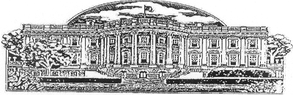

REQUEST FOR ISSUANCE OF
PRESIDENTIAL MEMORIAL CERTIFICATE

ELIGIBILITY

Eligible recipients include the next of kin, other relatives or friends. The award of a certificate to one eligible recipient does not preclude issuance to another eligible recipient.

Name of Deceased Veteran_____________________________________________________________

Name and Title of Person
Requesting Certificate
(Mr., Mrs., Miss, Ms of next of kin)______________________________________________________

Relationship to Deceased Veteran________________________________________________________

VA File Number (of Deceased) (if applicable) ______________________________________________

Social Security Number (of Deceased) ____________________________________________________

Telephone Number (include area code) _____ (_______) _____________________________________
(of recipient)

Mailing Address (of recipient) ___________________________________________________________

City ______________________________ State__________________________ Zip Code____________

Date ______________________________

Please Note: A Certified copy of the death certificate of the deceased veterans must accompany this request for issuance of Presidential Memorial Certificate.

